Questions:

**Do you want a website or an app?**

-“Sometimes we also get requests from abroad.”

**Is it a different price depending on the location?**

* “I can’t track all this information”

**What information do you need to collect?**

- “Right now employees fill out a timesheet on paper at the end of the week for the project. They submit these to our administration, who then input it into Excel.”

**Do you want it as tabular form of days or in a text format?**

1. **Variant**

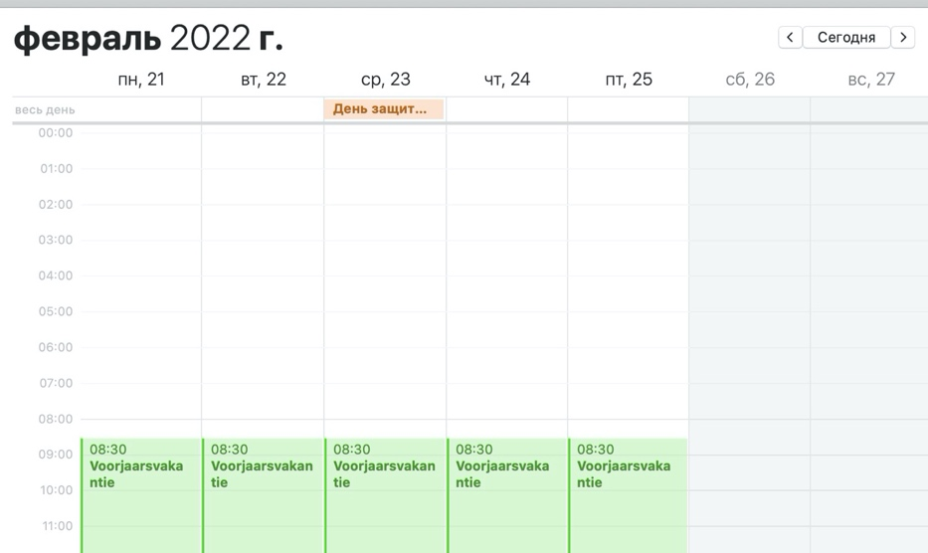

1. **Variant**

Dates for using: 23-26 feb

Time: 12:00-16:00

Customer: Luis

Responsible emp: John

etc

- “Currently for our business management we do analysis in Excel afterwards. We would like to keep this option so that we can use Excel to examine and manipulate the data.”

**On each page of the timetable will be also a button “Export to Excel”. OR we can build in excel in our program.**

**Can customers visit your website/app and see the planning of work, make some notes?**

Pages:

* Login, registration
* Personal page for employee, administration. (In personal page for employees will be a timetable, and for administration there will be buttons “confirm”, “edit”, “send message to employee” etc.)
* Planning timetable (for event: choose controllers, responsible employee, customer)
* Customer page (with all customer information, events (dates) and controllers that he needed, place, time etc)
* Page with all traffic controllers, from this information we pick controller for event. Also, there will be a quantity of controllers.
* Page for salaries to employees (**How to calculate a salary? On which bank account it will be sending? (maybe it will be specified in the employee's personal account)** )
* Page for making invoices to customers (**How to calculate a price?**)